PART 1

1. What is the Free Software Foundation/GNU? How is the Linux operating system related to GNU?
The Free Software Foundation (FSF) is a non-profit organization that was created by Richard Stallman to support the free software movement, which promoted the freedom to study, distribute, create, and modify computer software. The FSF sponsors the GNU project, which was launched to create a completely free, Unix-like operating system. Linux is just a kernel (the core component that manages hardware). It is related to GNU because the complete operating system uses GNU's tools, libraries, and utilities. Because of this, it is properly referred to as the GNU/Linux operating system.

2. What is a shell? How does it work with the kernel?
A shell is a command-line interpreter that acts as the user interface for the operating system. It accepts human-readable commands that you type, translates them into instructions the operating system can understand, and passes them to the kernel. The kernel then interacts directly with the hardware to execute the tasks and sends the output or results back to the shell to be displayed on your screen.

3. What language is Linux written in? How does the choice of language make Linux a popular operating system?
Linux is written primarily in the C programming language, which is a highly portable and efficient language that allows for low-level memory and hardware manipulation. This portability means the Linux kernel can be easily adapted to run on a variety of hardware architectures, from supercomputers and servers to desktop PCs and tiny devices.

4. Assuming you are currently under your own home directory, will the following command work? Explain why. cd /bin/cat
No, this command will not work. The cd command stands for "change directory," meaning its target must be a folder. The path /bin/cat points to an executable program file (the cat utility used to read files), not a directory. The system will return an error “Not a directory."

5. What are the folders /dev, /dev/null used for? Where did you find this information? (Cite your references)

/dev: This directory contains special device files that represent the hardware components (like hard drives, keyboards, USBs) and virtual devices attached to the system. It allows software to interact with hardware using standard file input/output operations.
https://refspecs.linuxfoundation.org/FHS_3.0/fhs/ch03s06.html

/dev/null: This is a special virtual device file known as the "null device" or "black hole." Any data written to /dev/null is immediately discarded, and any process that tries to read from it will immediately receive an end-of-file (EOF) signal. It is commonly used to hide unwanted output from commands.
https://man7.org/linux/man-pages/man4/null.4.html

PART 2

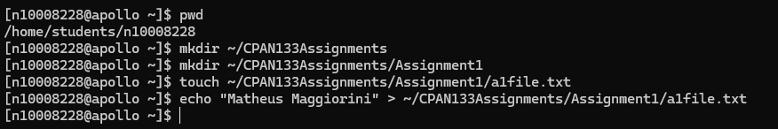

f. What is the absolute path to a1file.txt?
/home/students/n10008228/CPAN133Assignments/Assignment1/a1file.txt

g. What is the relative path to a1file.txt assuming your current directory is your home directory?
CPAN133Assignments/Assignment1/a1file.txt

